**Central Tedency**

Dataset : Placement.csv

**Calculating Mean, Median and Mode:**

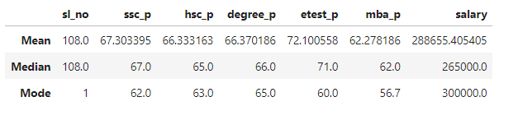

**MEAN:**

|  |  |  |
| --- | --- | --- |
|  | **Mean (Average) Score** | **Performance** |
| **ssc_p** | 67.33095 | Above Average |
| **hsc_p** | 66.333163 | Above Average |
| **degree_p** | 66.370186 | Above Average |
| **etest_p** | 72.100558 | Good |
| **mba_p** | 62.278186 | Above Average |
| **salary** | 288655.405405 | Reasonable |

* From the above calculations of Average Score, Students performed **Above** **Average** SSC, HSC, Degree and MBA.
* Comparing these to **employability test**, students performed well and **good**. So they get **better salary** on their placement.

**MEDIAN:**

|  |  |  |
| --- | --- | --- |
|  | **Median Score** | **Performance** |
| **ssc_p** | 67.0 | Above Average |
| **hsc_p** | 65.0 | Above Average |
| **degree_p** | 66.0 | Above Average |
| **etest_p** | 71.0 | Good |
| **mba_p** | 62.0 | Above Average |
| **salary** | 265000.0 | Reasonable |

* From the above calculations of Median, Students performed **Above Average** SSC, HSC, Degree and MBA. There is no drastic change compared to the mean Value.
* Comparing these to **employability test**, students performed well and **good**. So they get **better salary** on their Placement.
* Comparing Salary with mean, **median avoids outliers** that mean contains.

**MODE:**

|  |  |
| --- | --- |
|  | **Mode (Most Common) Score** |
| **ssc_p** | 62.0 |
| **hsc_p** | 63.0 |
| **degree_p** | 65.0 |
| **etest_p** | 60.0 |
| **mba_p** | 56.7 |
| **salary** | 300000.0 |

* Above Table Shows, most common **repeated scores** of the students secured in SSC, HSC, Degree and MBA.
* From the Mode, Most number of students got **higher salary** ‘**300000’** on the placement.